USER GUIDE

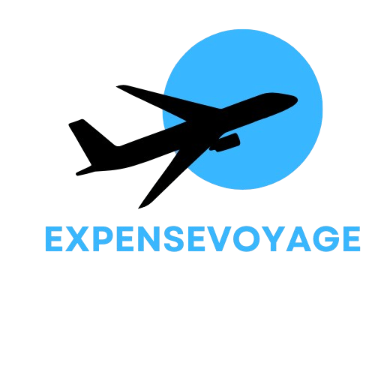

1. *About:*

*Welcome to Expense Voyage:*

*Our new and simple travel expense platform. Tracking your money when on an adventure, either solo or with a group can be daunting. Between collecting receipts, tracking where your money went, and what you spend for travel often turns controlling the purse strings into a bit of a nightmare. We at expense Voyage provide a solution to track your travel expenses to keep you organized and within the limit. Profiles. Join us in revolutionizing salon management – where beauty meets technology. Elevate your salon experience with us!*

1. *User Sitemap:*

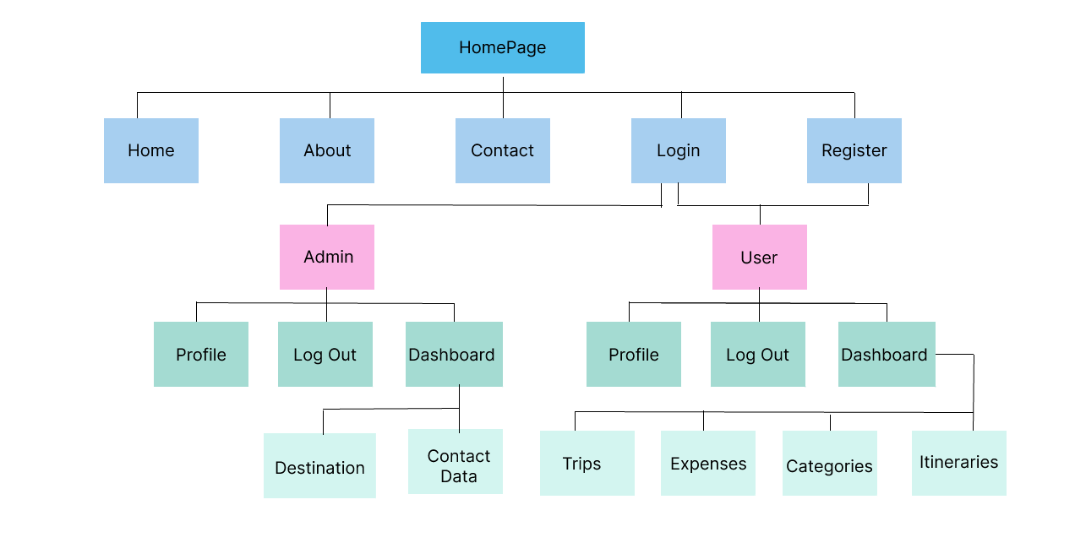

*Home Page*

*1.Header:*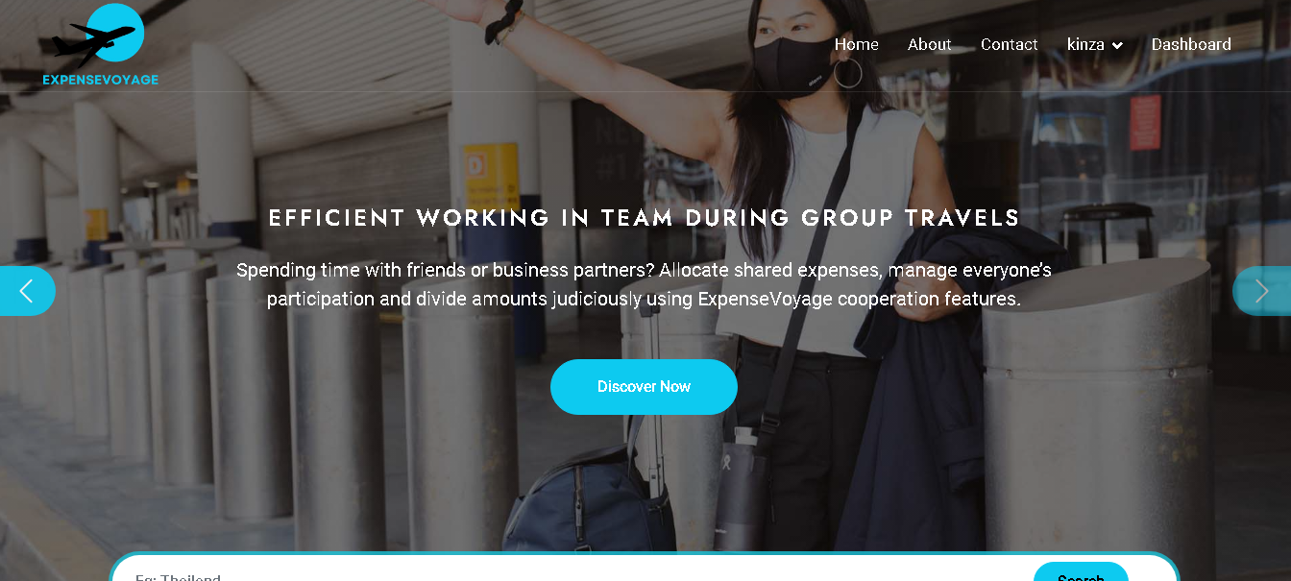

*About Us Page*

*In this page user can give us many information.*

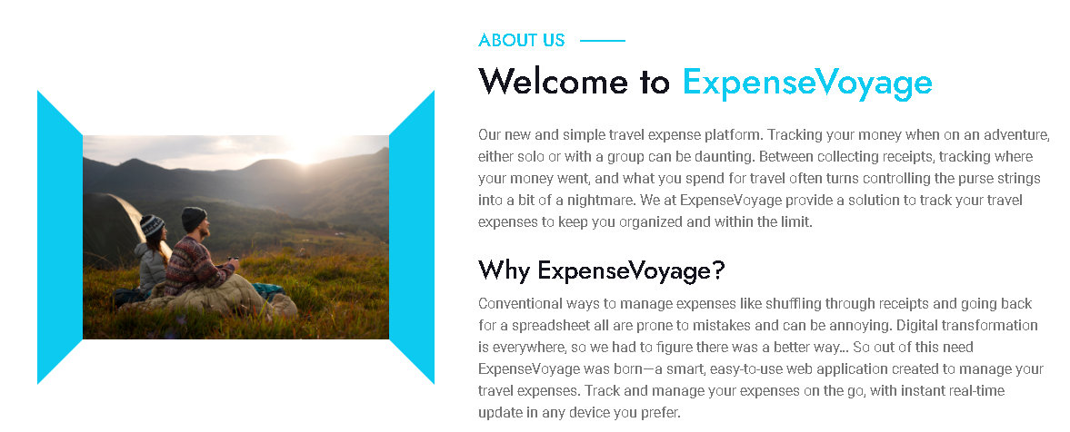

*2.Services:*

*In this section user can see services for this website.*

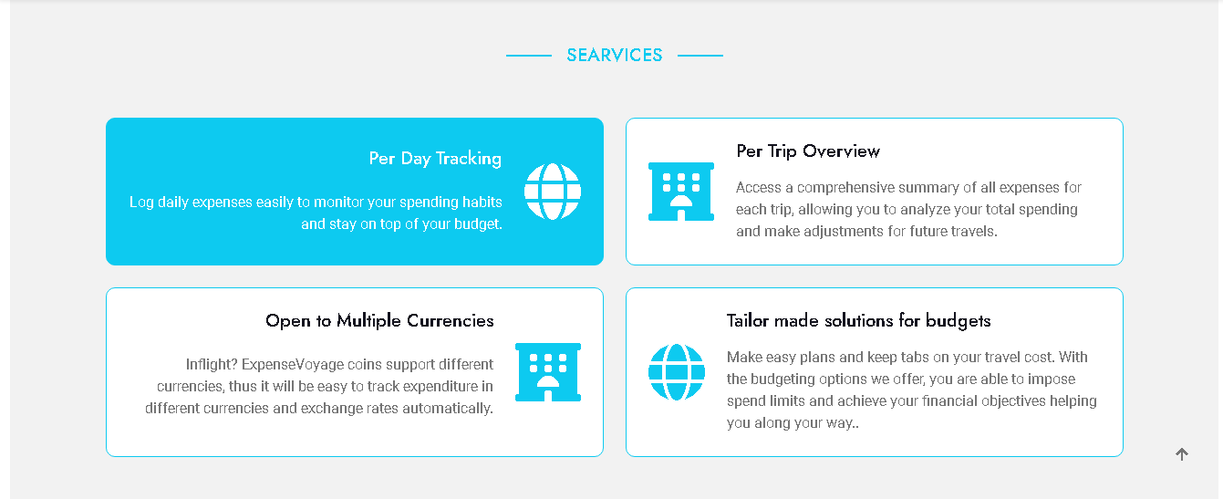

*3.Destination: In this section user can see Destination*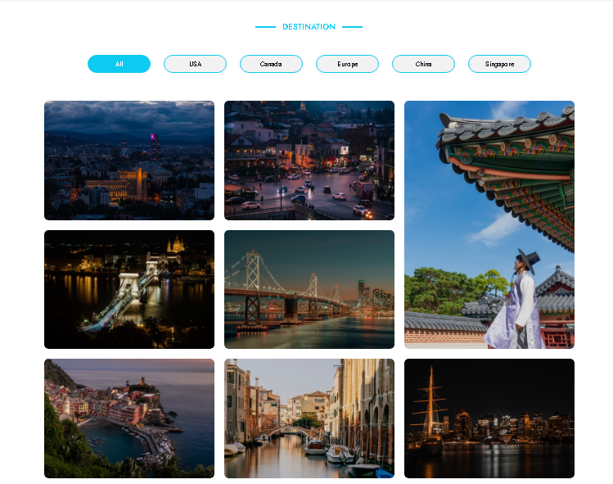

*4.Contact Us Page*

*In this page user can easily contact with us.*

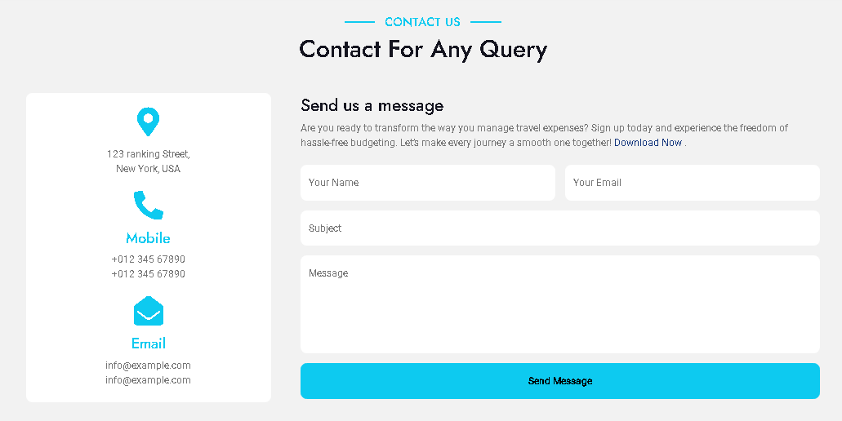

*5.Footer*

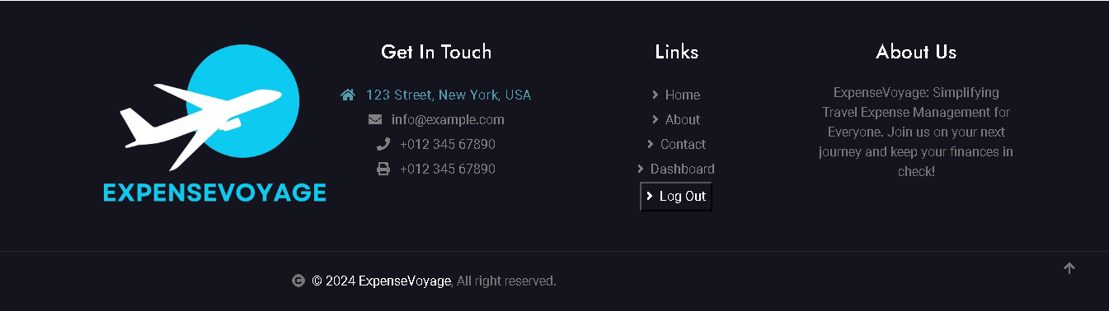

***User Dashboard***

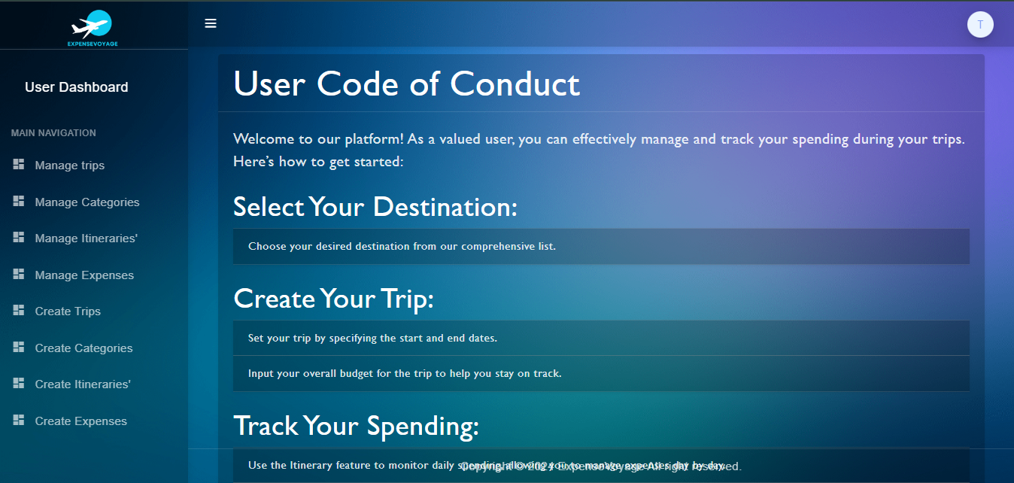

*Admin Dashboard*

*In this dashboard only admin can see all works and handle the website like export into excel file, add, fetch, delete, update and also included logout function.*

